Task 1- Kitchen Sized
The rectangular floor plan of the first level of a house is shown in
the following diagram:
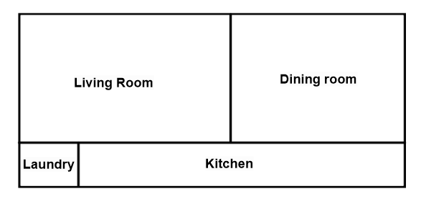
Both the laundry room and the dining room are square with areas of 4 m² and 25m², respectively. The living room is rectangular, with an area of 30m². Determine the area of the kitchen.
Possible Answers:
a) 16 m² c) 14m²
b) 18m² d) 21m²

Task 1- Kitchen Sized

Answer | Correct (Yes or No) | Mathematical Explanation  (Show all steps) | Communicate the Errors or Correct response using words
a) 16 m²

b) 18m²

c) 14m²
d) 21m²

Task 2
Success Criteria:
-Ruler was used throughout for the design
-Picture/diagram makes sense (ex-scale and area)
-Question posed is relevant to the diagram, clear and grammatically correct
-Calculations are shown for each answer (step by step/ 1 = sign per line)
-Proper units used throughout (ex- cm² vs cm³)
- “Therefore” statement provided for each answer (correct (1) and errors (3))

Learning Goals:
-Determine, through investigation using a variety of tools the relationships among area, perimeter, corresponding side lengths similar shapes.
- Describe, and report on applications of area and capacity measurement.
- Reflect on and evaluate your own work and the work of another student.
-Create a well-developed, multi-step inquiry problem.
-Gain useful feedback from students in class.

Task 2/3 Rubric
Category | Level 4 | Level 3 | Level 2 | Level 2
Questions | Questions were detailed well thought out. All the criteria were followed (success criteria listed on board) throughout. | Questions were well thought out and developed. Most of the criteria was followed (success criteria listed on board) throughout. | Questions were lacking detail and complexity. Some of the criteria was followed (success criteria listed on board) throughout. | Questions were missing components and complexity. Most of the criteria was missed (success criteria listed on board) throughout.
Steps | All work and calculations were shown with detail. No errors throughout steps. Detailed written explanation for each problem was provided. | Most of the work and calculations were shown. Little to no errors throughout steps. Written explanation for each problem was provided. | Some of the work and calculations were shown. Some errors throughout procedural steps. Some explanations were written and provided. | Very little work and calculations were shown. Numerous errors throughout steps. Answer weren’t communicated or explained.
Solving other problems | Solutions and explanations were detailed and thorough. Provided great feedback for students from other groups. | Solutions and explanations were well developed. Solutions provided good feedback for students from other groups. | Solutions and explanations were missing some detailed and thought. Answers provided some feedback for students from other groups. | Solutions and explanations weren’t detailed or thorough. Provided little to no feedback for students from other groups
Class Time | Class time was used effectively and efficiently when creating problems, finding solutions and solving the questions from other students. | Most of the class time was used effectively and efficiently when creating problems, finding solutions and solving the questions from other students. | Some of the class time was used effectively and efficiently when creating problems, finding solutions and solving the questions from other students. | Class was not used effectively and efficiently when creating problems, finding solutions and solving the questions from other students.

